**Use Case1: Test Restore**

**Restoring a random file from a random server to test the restore process of backed up data.**

**Test Case 1 (Windows server)**

1. **Shows the empty restore destination directory in target server**

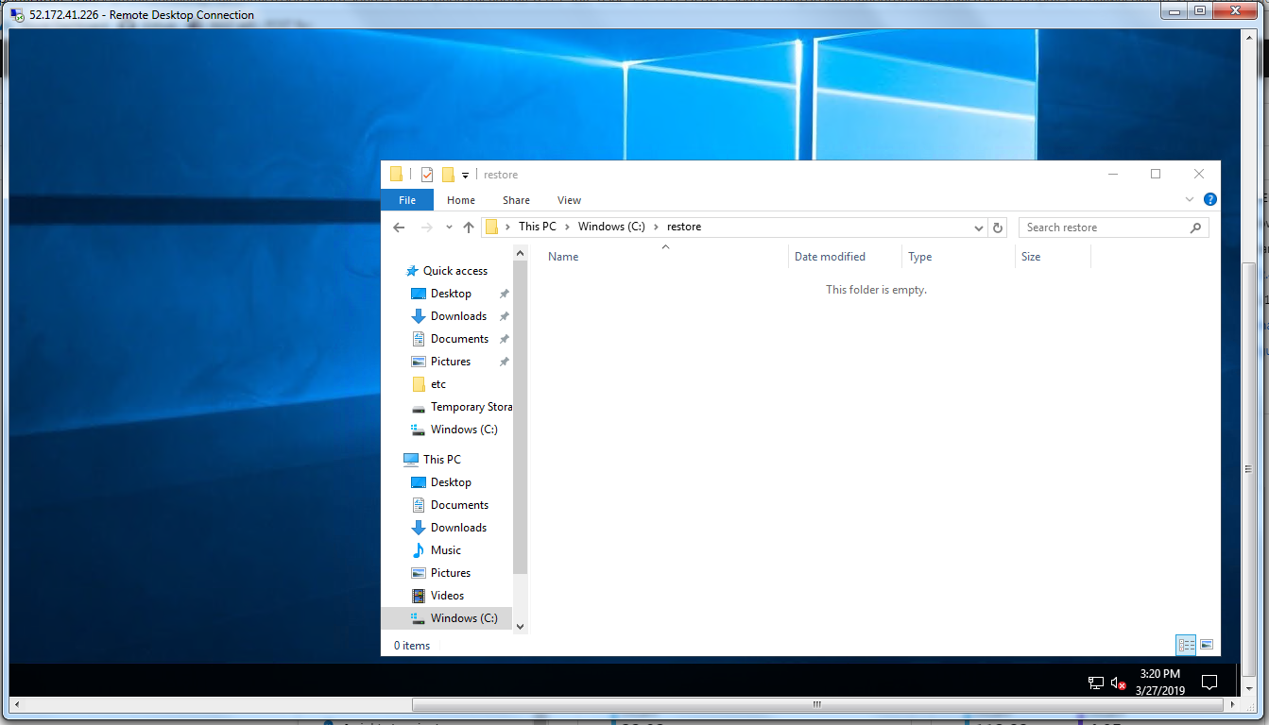

1. **Running the script for restoring file backed up in last 24 hours as highlighted in the script.**

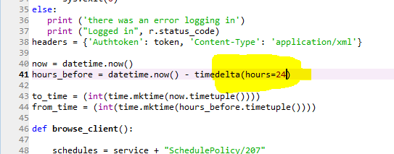

1. **Selected a random file in a random server from the backup to restore** 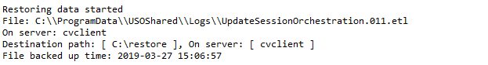
2. **Created a backup job and completed the restore**



1. **File restored to the target server.**

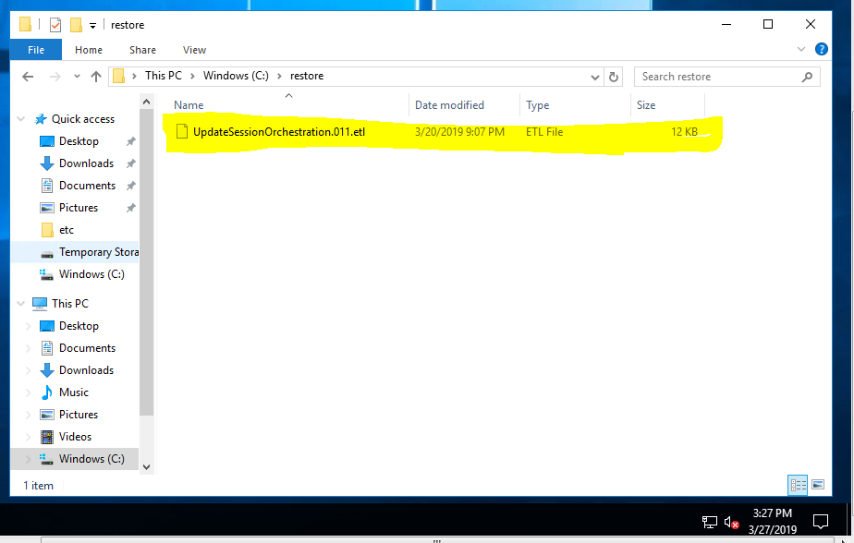

**Test Case 2 (Linux Server)**

1. **Shows the empty restore destination directory in target server**

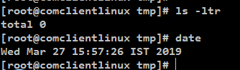

1. **Running the script for restoring file backed up in last 24 hours as highlighted in the script.**



1. **Selected a random file in a random server from the backup to restore**

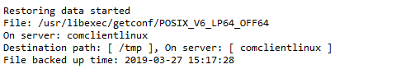

1. **Created a backup job and completed the restore**



1. **File restored to the target server.**

